Introducing Shavuot
Continuing our occasional theme of the Jewish feasts, we come to Shavuot, the Feast of Weeks. By Jesus’ day it was also known by the Greek word Pentecost, which means 50 days. The feast takes place 50 days after Passover.
God instituted the feast when the Israelites were still in the desert, looking forward to when they would be in the land and harvesting crops. The festival of First Fruits a few days after Passover celebrates the new barley harvest and Shavuot celebrates the next harvest, wheat. It was simply a harvest festival, a thanksgiving for God’s provision of grain and animals.
But by Jesus’ day, it had also become the time to celebrate the giving of the Torah (the first five books of the Bible). As a celebration, it’s very different from Passover: the Passover meal is unleavened bread, roast lamb, bitter herbs and wine. Eaten to remember the hasty meal and journey out of Egypt. 50 days later, Shavuot is a time to study and celebrate God’s Word together, a time of scented flowers, fruit, dairy products and leavened bread. Calling to mind the good things God provided in the land flowing with milk and honey.
------------
Imagine yourselves in Jerusalem, the weather is heating up, the land is beautiful, full of flowers after the spring rains. The city is heaving with people who’ve come to Jerusalem for the feast.
You have celebrated the Biblical feasts every year since you were little, you know the sacrifices, the scripture passages, the history, but this year has been different.
Only seven weeks ago, you celebrated Passover and First Fruits. You’d got caught up in the excitement of the promised Messiah, joined the procession into the city, crying Hosanna as Jesus rode by on a donkey. But then you’d witnessed his crucifixion and heard the rumours that his body had been stolen and now new rumours are circulating: he’s been seen on the road, he’s been seen in local towns, by the lake in Galilee. You don’t know what to think. The Sanhedrin act confident but they’re on edge. They need this feast to go well, they don’t want to upset the Roman authorities after what happened at Passover. But now Jesus’ disciples are back in the city, they’re worshipping at the Temple, and the Messiah is no-where to be seen….
The day of Shavuot/Pentecost arrives and you go to the Temple in the morning to hear the scriptures and to study them with other devout Jews. The first reading you hear is from the Torah, the reading for this feast is Exodus 19 and 20. You hear about the Israelites consecrating themselves at Mount Sinai because God is coming to meet with them…
READING 1 - Exodus
19 v 16- 20 On the morning of the third day there were thunders and lightnings and a thick cloud on the mountain and a very loud trumpet blast, so that all the people in the camp trembled.
Then Moses brought the people out of the camp to meet God, and they took their stand at the foot of the mountain. Now Mount Sinai was wrapped in smoke because the Lord had descended on it in fire. The smoke of it went up like the smoke of a kiln, and the whole mountain trembled greatly. ¹⁹ And as the sound of the trumpet grew louder and louder, Moses spoke, and God answered him in thunder. ²⁰ The Lord came down on Mount Sinai, to the top of the mountain. And the Lord called Moses to the top of the mountain, and Moses went up.”
20 v 18-21 Now when all the people saw the thunder and the flashes of lightning and the sound of the trumpet and the mountain smoking, the people were afraid and trembled, and they stood far off ¹⁹ and said to Moses, “You speak to us, and we will listen; but do not let God speak to us, lest we die.” ²⁰ Moses said to the people, “Do not fear, for God has come to test you, that the fear of him may be before you, that you may not sin.” ²¹ The people stood far off, while Moses drew near to the thick darkness where God was.
Then you hear a portion from the prophets, for Pentecost the designated reading is Ezekiel 1 and 2.
READING 2 – Ezekiel chapter 1 v 2-5, 12, 26, 28b, chapter 2 v 1-2, 6, 7
On the fifth day of the month …the word of the Lord came to Ezekiel the priest, the son of Buzi, in the land of the Chaldeans by the Chebar canal, and the hand of the Lord was upon him there. As I looked, behold, a stormy wind came out of the north, and a great cloud, with brightness around it, and fire flashing forth continually, and in the midst of the fire, as it were gleaming metal. And from the midst of it came the likeness of four living creatures…Wherever the spirit would go, they went, without turning as they went….
And above the expanse over their heads there was the likeness of a throne, in appearance like sapphire; and seated above the likeness of a throne was a likeness with a human appearance….
Such was the appearance of the likeness of the glory of the Lord. And when I saw it, I fell on my face, and I heard the voice of one speaking.
And he said to me, “Son of man, stand on your feet, and I will speak with you.” And as he spoke to me, the Spirit entered into me and set me on my feet, and I heard him speaking to me. And He said to me, “Son of man, I send you to the people of Israel, to a nation of rebels, who have rebelled against me...”
“And you, son of man, be not afraid of them, nor be afraid of their words, though briers and thorns are with you and you sit on scorpions. Be not afraid…And you shall speak my words to them, whether they hear or refuse to hear…
The thought of hearing from God sends shivers up your spine. And then…
READING 3 - Acts 2 v 2-12
And suddenly there came from heaven a sound like a mighty rushing wind, and it filled the entire house where they were sitting. And divided tongues as of fire appeared to them and rested[a] on each one of them. And they were all filled with the Holy Spirit and began to speak in other tongues as the Spirit gave them utterance.
Now there were dwelling in Jerusalem Jews, devout men from every nation under heaven. And at this sound the multitude came together, and they were bewildered, because each one was hearing them speak in his own language. And they were amazed and astonished, saying, “Are not all these who are speaking Galileans? And how is it that we hear, each of us in his own native language? Parthians and Medes and Elamites and residents of Mesopotamia, Judea and Cappadocia, Pontus and Asia, Phrygia and Pamphylia, Egypt and the parts of Libya belonging to Cyrene, and visitors from Rome, both Jews and proselytes, Cretans and Arabians—we hear them telling in our own tongues the mighty works of God.” And all were amazed and perplexed, saying to one another, “What does this mean?”
When God was giving the law to Moses on Mount Sinai, I wonder if he got to the Pentecost instructions and thought “Moses, you think this is just a simple harvest festival, but you wait and see!”.
The three passages we’ve heard are very different, in location, the people involved, their circumstances. But there is one constant: the awesomeness of God’s presence.
In Exodus, the people are hedged about with warnings. God has chosen them and has promised that they will be His treasured possession if they obey Him, but even so the people can only approach to a certain distance, and then only when they are consecrated. If they touch the mountain or try to break through the cloud to see God, they will die.
When God’s presence surrounds the mountain, it is covered with cloud and fire. There is the sound of thunder and a trumpet, so loud that the ground is shaking.
The warnings seem unnecessary. The people were so terrified that they didn’t want to approach.
The Hebrew word that is translated as ‘thunder’ here, is more correctly translated as voice; so it seems that the people could hear the sound of voice of God. But even that was too much for them. They didn’t want to hear God’s voice directly, they wanted Moses to mediate for them.
Only a few weeks before, they had witnessed the power of God in Egypt. Apart from Moses, they don’t know God personally: they know how He has punished Egypt, they’re received his provision for them and witnessed His anger, and now He wants to see them all together. For most of them, their perception of Him is still founded in Egypt: the gods are capricious and angry, you appease them with sacrifices and maybe they will give you a good life. You can’t know them personally. The people have spent their whole lives knowing about those sorts of gods and now they’re facing Someone completely different. For the majority, their old understanding means they are at the mountain in obedience that’s based on fear of punishment and a hope of reward, or at least of survival. Their old thinking is still entrenched.
God has come in power to the mountain in order to test His people. Moses tells them “Do not fear, for God has come to test you, that the fear of him may be before you, that you may not sin.”
Centuries later, the devout men and women listening to this reading at the Temple would have remembered God’s promise of blessings to those who obey His Law, who fear Him and who teach their children. They would also have remembered how their ancestors had been disobedient and had been sent into exile. Their hearts were distant from God and the curse meant that they were separated physically from God’s presence at the Temple and from the Land.
Although a remnant had returned to Jerusalem with Ezra and other leaders. Many, perhaps as many as 90% of the people, had settled in the lands of Babylon, Persia and Media and hadn’t returned to Jerusalem. Now some of their descendants had travelled to Jerusalem for the feast and were studying the words of Moses and Ezekiel together.
The location in the Ezekiel passage is very different from the Exodus one. Ezekiel is in the flat, fertile land of Babylon, in the delta where the Euphrates and Tigris rivers head to the sea. He is among the other exiles, but is set apart. He is a priest, a Levite, and the only one by the canal to witness this vision.
Like the Israelites, he witnesses fire and a great cloud. Unlike them, he is allowed to see within the cloud and sees living creatures whose every move is obedient to the spirit of God. Wherever they are sent, they go straight ahead not wavering to the left or the right.
But then there is the most overwhelming moment: Ezekiel is permitted to see in the vision what Moses saw as a glimpse: the glory of the LORD.
The Israelites were warned if they tried to see God they would die. When Ezekiel fell on his face, he must have expected death, but he does not die. Instead he hears God’s voice speaking to him personally. He is filled with God’s spirit and commissioned to speak to the rebellious nation, whether they listen or not.
---------
There are so many parallels between these events and what happened on that day of Pentecost that it cannot be coincidence. We don’t know which priest decided to link the feast to Mount Sinai or who chose those passages for the readings, but I’m sure they were prompted by God.
Since the resurrection, the disciples hadn’t been moping around. They had done some travelling – to Emmaus, to Galilee - but then Jesus had told them to return to Jerusalem and wait for God to send His Spirit. They didn’t know how long they had to wait or what exactly would happen. It must have been quite tempting to think ‘I’ll just nip over the Bethany to tell my friend what’s happened’ or ‘I’ll just go and do some fishing and be back in a couple of days’. But they didn’t: like the Israelites they obeyed and waited.
And like the Israelites, they were called to be ‘all together in one place’: the whole nation had stood at the foot of Mount Sinai, now the disciples were meeting together, probably in the Temple precincts. This was the only place in the city where so many people could hear them speak – and of course very convenient for getting to the baptismal baths!
But there are also differences between the events.
1.This time the people are not kept at a distance by God’s warnings, they are actually on the mountain. The Temple Mount is on Mount Moriah, where Abraham went to sacrifice Isaac, which is also called Mount Zion.
2. They are not braced to try and appease an unknown God, they know Him. They’ve walked with Him, eaten meals with Him, they know His heart.
3. They are not keeping well back, trembling with terror, they are eagerly awaiting what God will do.
4. When God’s spirit descends on them, it is not with the awesome power He displayed at Mount Sinai or the incomprehensible splendour of Ezekiel’s dream. It is with a rushing wind and with tongues of fire. God has come close to the mountain in a new way.
5. His presence doesn’t make the disciples to fall flat on their faces or cause a stampede out of the Temple. No, He gives the disciples the ability to speak to everyone present. Jesus promised them in John 16 v 13 that “When the Spirit of truth comes, He will guide you into all the truth, for He will not speak on His own authority, but whatever He hears He will speak…”
The disciples haven’t changed outwardly, they are still recognisable as ordinary Galileans, but they are speaking the words that God has given them in the languages that He has given them.
6. Those present are amazed but not terrified, they are curious or attracted or repelled by what they hear and see.
The people present are Jews or proselytes, that is gentiles who have converted to Judaism, from all over the region. They are descendants of the exiles who stayed in Babylon and Persia, Jews who left Judea by choice or compulsion under the Greek and Roman occupations, and those who had come to know and love the Jewish God.
They have come from the regions of Egypt, from what used to be Assyria, Crete, from Asia, North Africa and Rome. They have travelled on the great trading routes to be in Jerusalem to be here, the Way of the Sea, the Silk Roads and the sea routes. And at some point they will return that way, to tell their families and neighbours what they have witnessed.
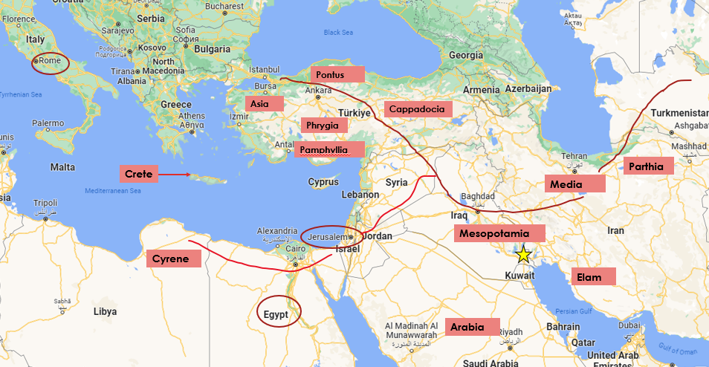

On that feast of Pentecost, God started the work of re-uniting the Jewish people regardless of where they live and the language they speak, as He promised in Isaiah 11 v 12:
“He will raise a signal for the nations and will assemble the banished of Israel, and gather the dispersed of Judah from the four corners of the earth.”
In that first day, 3,000 Jews accepted Jesus as the Messiah, believing the words that God gave the disciples. God added more believers day by day.
The work starts first with Israel but doesn’t stop there. God calls the people of Israel back to Himself and through them His spirit will draw all the nations. All were rebellious, but all now have the opportunity to approach. Isaiah 66 v18 says
“For I know their works and their thoughts, and the time is coming to gather all nations and tongues. And they shall come and shall see my glory,”
We are the fruit of that work and also the workers.
In God’s great generosity and love, He sent His spirit to the gentiles as well as to His own chosen people.
Like the disciples in Jerusalem on that day, let’s draw near to God and be obedient to his calling. Let’s invite Him to fill us with His spirit and be prepared to go where he sends us, going straight ahead not wavering.
We have a time now to listen to God, talk to Him. We’ll hear a song that also shows the fruit of God’s work: One for Israel works with Jews, Arabs and Christians who follow Jesus in Israel. This song is sung in Hebrew, Arabic and English, Jews and gentiles praising God together.
“Way maker” https://www.youtube.com/watch?v=HhbtVCI67pw

